Q1.
Answer is C.

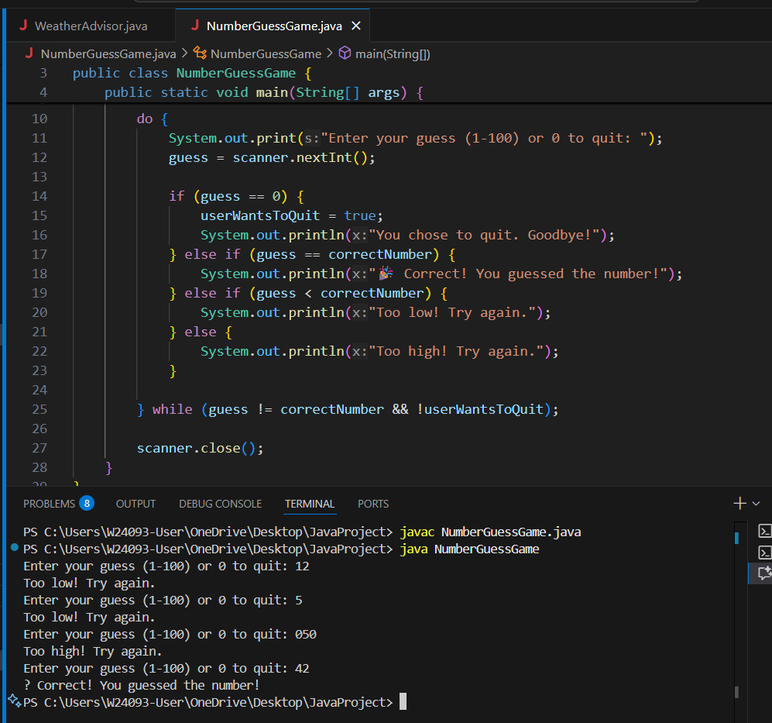

A: For loops aren’t meant for unknown counts.

B: Works but less clean (uses break).

C: runs at least once, clear logic.Correct.

D: Infinite loop.Incorrect.

Q2.
Answer is C.

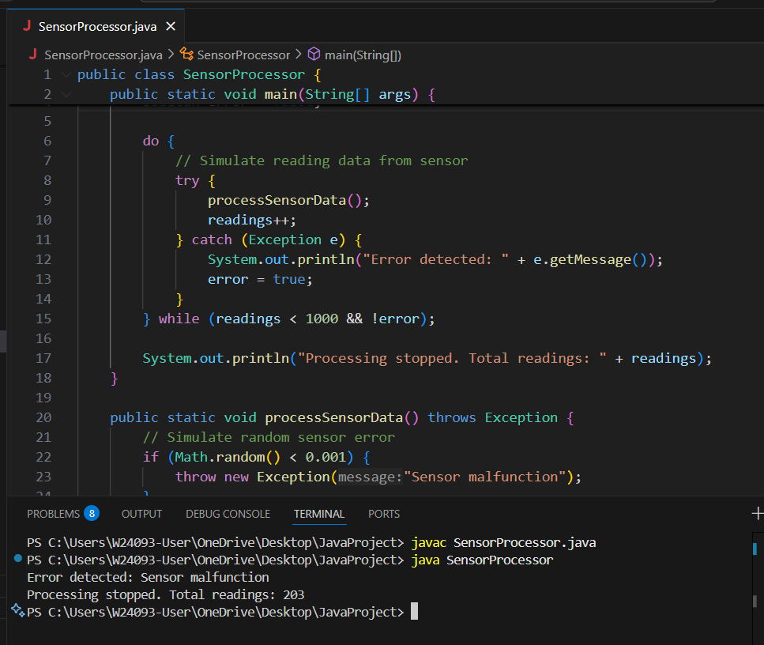

A: For loop better for fixed iterations.

B: Works but needs explicit break for error.

C: Clean, handles at least one reading, stops on condition.

D: Only works for finite collections, not real-time streams.

Q3.
Answer is C.

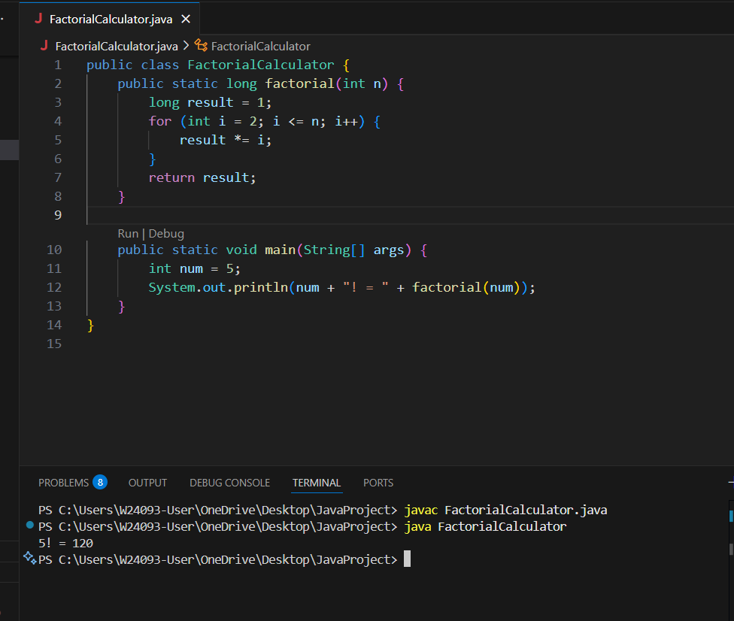

A: Modifies n directly, slightly less clean.

B: Do-while unnecessary.

C: Correct and efficient.

D: Infinite loop + break, poor style.

Q4.
Answer is A.

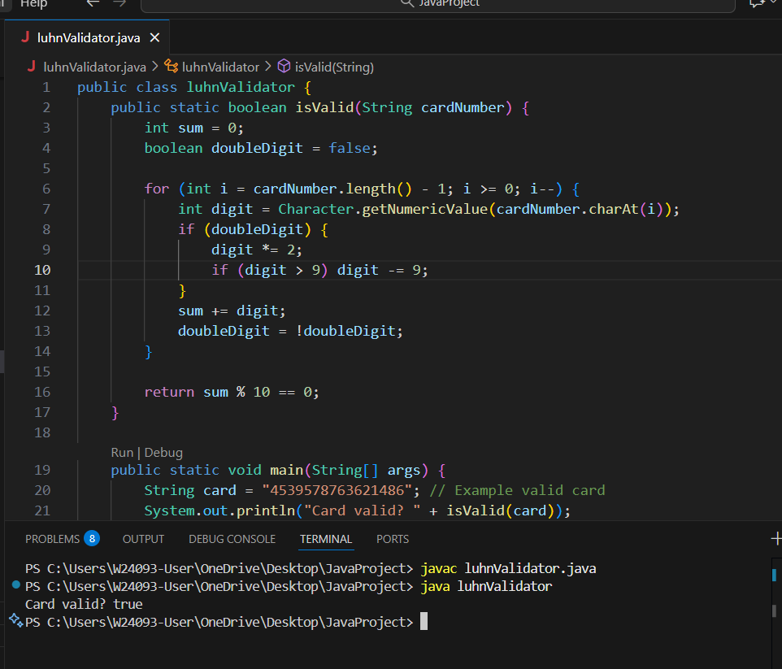

A: Correct for Luhn processing.

B: Works but less clean.

C: Unnecessary do…while.

D: Not suitable for Luhn algorithm.

Q5.
Answer is A.

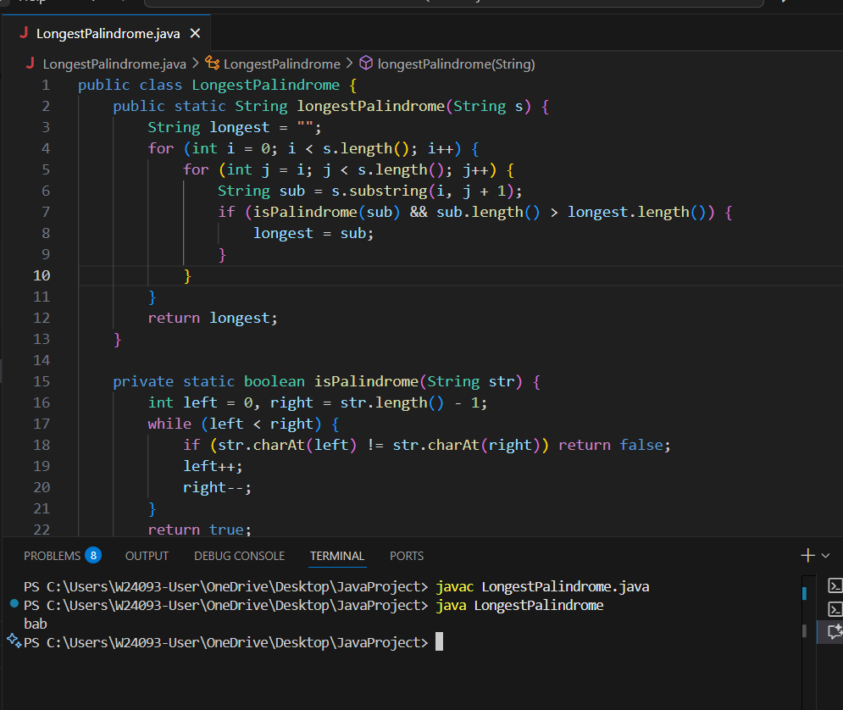

A: Best for brute-force substring check.

B: Works but not as clean.

C: Works, but unnecessary here.

D: Cannot get substrings using chars.

Q6.
Answer is B.

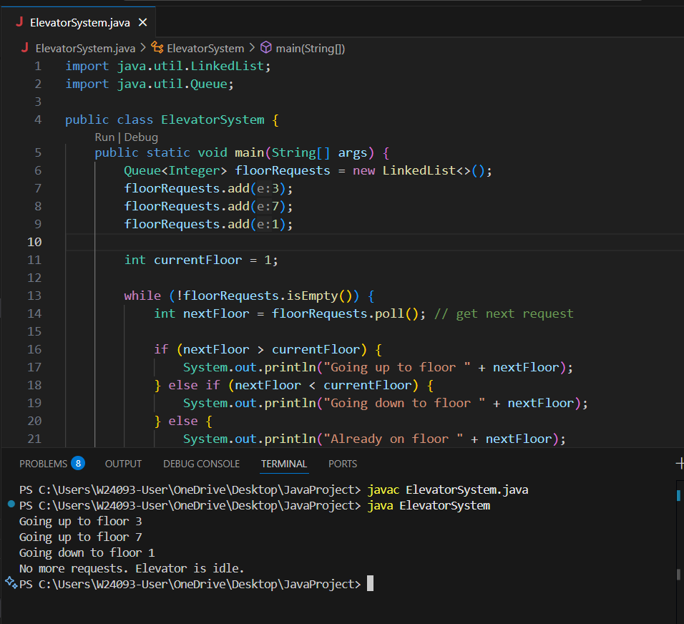

A: Not suitable for a reactive elevator system.

B: Best for dynamic floor request processing.

C: Less clear, requires extra logic.

D: Only work for fixed collection at start.

Q7.
Answer is A.

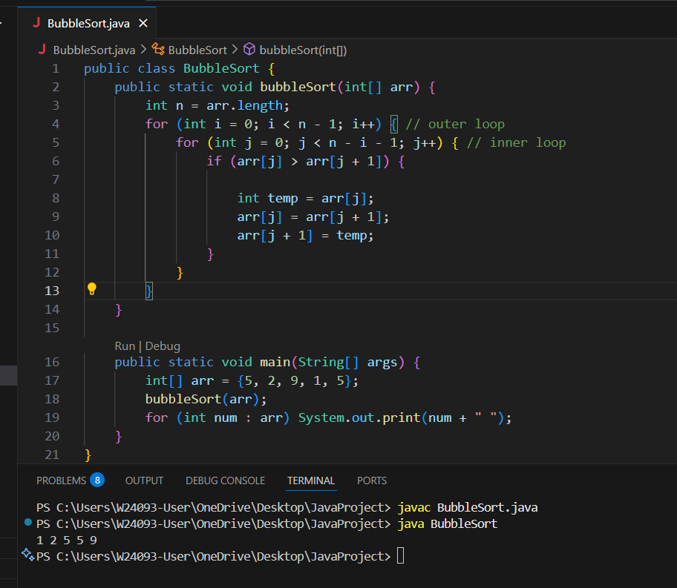

A: Best for outer loop, clean.

B: Requires extra swapped flag.

C: Do…while works but less conventional.

D: Cannot handle swaps over indices.

Q8.
Answer is B.

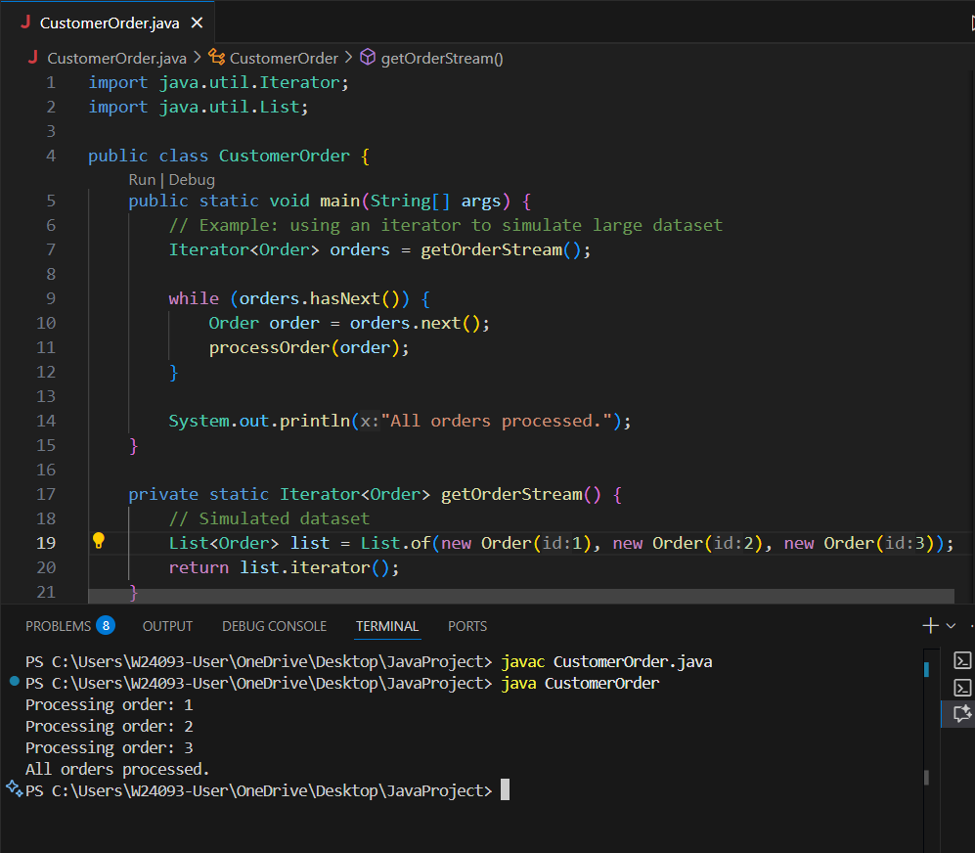

A: Not suitable for unknown-length.

B: Best for unknown datasets.

C: Cannot handle lazy loading or iterators without Iterable.

D: Only works with in-memory collections.

